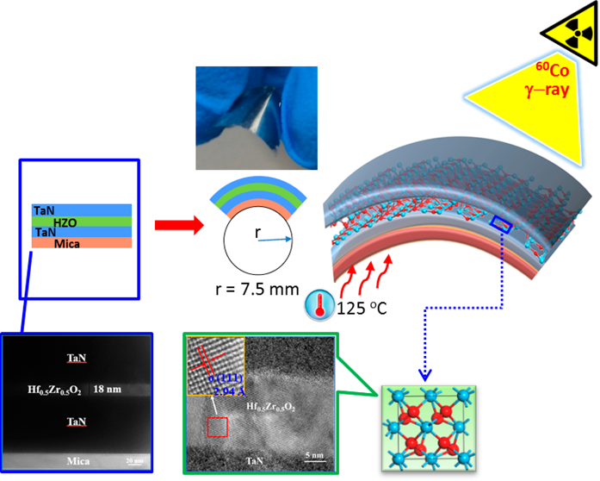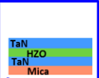

Article Cite This: [ACS Appl. Electron. Mater. 2019, 1, 919−927](http://pubs.acs.org/action/showCitFormats?doi=10.1021/acsaelm.9b00107)  pubs.acs.org/acsaelm

Thermally Stable and Radiation Hard Ferroelectric Hf0.5Zr0.5O2 Thin Films on Muscovite Mica for Flexible Nonvolatile Memory   
Applications

|  |  |  |  |  |  |
| --- | --- | --- | --- | --- | --- |
| :51 (UTC).  hed articles. | Wenwu Xiao,†Chen Liu,†Yue Peng,‡Shuaizhi Zheng,*,†Qian Feng,‡Chunfu Zhang,*,‡  Jincheng Zhang,‡Yue Hao,‡Min Liao,*,†and Yichun Zhou†  †Key Laboratory of Low Dimensional Materials and Application Technology of Ministry of Education, School of Materials Science  and Engineering, Xiangtan University, Xiangtan 411105, People’s Republic of China  ‡State Key Discipline Laboratory of Wide Band Gap Semiconductor Technology, School of Microelectronics, Xidian University,  Xi’an 710071, People’s Republic of China  * S Supporting Information | | | | |
| Downloaded via GEORGIA INST OF TECHNOLOGY on November 26, 2019 at 16:28:51 (UTC).  See https://pubs.acs.org/sharingguidelines for options on how to legitimately share published articles. | ABSTRACT: Metal−ferroelectric−metal (MFM) capacitors on flexible sub-strates are promising for flexible nonvolatile memory applications, while the insufficient scalability of perovskite-based ferroelectric thin films and the difficulty of direct integration of high performance ferroelectric thin films on current conventional flexible substrates are the most serious obstacles to their practical  applications. Meanwhile, performance under harsh conditions (such as high  temperature and high total ionized dose (TID) radiation) is highly demanded  due to the growing applications for nonvolatile memory. Here, we integrate highly scalable ferroelectric Hf0.5Zr0.5O2 (HZO) thin films on potential flexible mica substrates using atomic layer deposition (ALD) to form flexible MFM  capacitors and investigate the ferroelectric properties, the retention behaviors, and endurance characteristics of the TaN/HZO/TaN/mica flexible MFM  capacitors under various tensile and compressive bending radii. In addition, these  characteristics of the HZO-based MFM flexible capacitors are explored in a wide temperature range from 25 up to 125 °C. The ferroelectricity of the film can be retained under a bending radius down to 7.5 mm after 1000 bending cycles, and the retention properties can be reserved under a bake time of 104s at 125 °C, with an extrapolated retention time-to-failure longer than 10 years. Furthermore, the flexible devices display robust ferroelectric performance against radiation of60Co γ-rays with a total dose of 1 Mrad (Si). Our work represents a critical step in HfO2-based ferroelectric memory implemented on mica toward flexible nonvolatile memory operated under harsh conditions.  KEYWORDS: ferroelectric, Hf0.5Zr0.5O2 (HZO), flexible, mica, thermally stable, radiation hard | | | | |
| ■INTRODUCTION  Ferroelectric random access memories (FeRAMs) are non-volatile ferroelectric memories that use ferroelectric films to store information. FeRAMs have attracted considerable attention because of their nonvolatility, low power con-sumption, high operation speed, and almost unlimited read/ write endurance.1−3Although mass production of FeRAMs that use lead zirconium titanate (PZT) integrated on rigid bulk silicon substrate commenced in 1992,4they are restricted to a niche market mainly including industrial applications, factory automation equipment, measuring equipment, power meters, bank terminals, and so on.5To take full advantage of FeRAMs, commercial vendors are putting great effort on developing new markets, where FeRAMs have found much broader applica-tions in automotive systems, robotic systems, medical devices, | | dose (TID) radiation7) desired for applications is gaining interest.  Furthermore, conferring flexibility to the electronics could dramatically enhance those applications for the emerging Internet of Things (IoT) fields.8,9To realize this aim, one crucial aspect is to fabricate the device on a flexible substrate. In the development of flexible devices, PZT ferroelectric capacitors were demonstrated on platinum (Pt) foil by using the transfer technique. However, Pt is not suitable for monolithic integration, and the achieved devices were not examined under harsh conditions.10Besides, PZT ferroelectric memories were fabricated on ultrathin flexible silicon (Si) substrates using soft-backside etching, focusing on harsh environment applications, yet the bending radius was 1.25 cm with the experimented devices, since an anomaly in | | |
| contactless smart cards, and food industry. As FeRAMs are | | | | |
| becoming more widely used, the demand for them is expected | | Received: | February 21, 2019 | |
| to increase; especially their performance under harsh conditions (such as high temperature6and high total ionized | | Accepted: | | May 10, 2019 |
| Published: May 23, 2019 | | |
|  | © 2019 American Chemical Society | 919 | DOI: [10.1021/acsaelm.9b00107](http://dx.doi.org/10.1021/acsaelm.9b00107) ACS Appl. Electron[. Mater. 2019, 1, 919−927](http://dx.doi.org/10.1021/acsaelm.9b00107) | |

|  |  |
| --- | --- |
| ACS Applied Electronic Materials | Article |

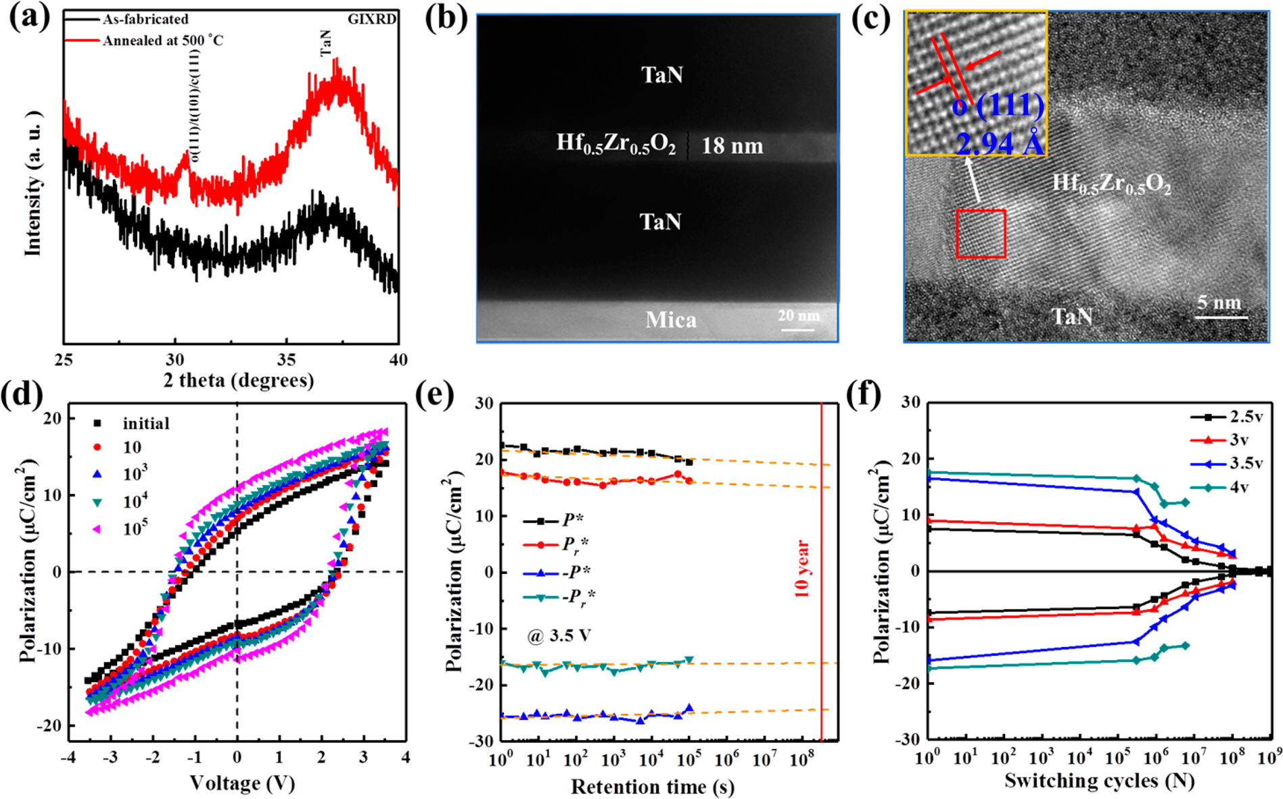

Figure 1. (a) GIXRD patterns of the as-fabricated and the annealed TaN/HZO/TaN/mica structures. (b) TEM image and (c) HRTEM image of the annealed structures; the inset of (c) shows the enlarged HRTEM image of the selected area marked by a red frame. (d) P−V hysteresis loops between 1 and 105bipolar switching cycles. (e) Retention and (f) endurance of the annealed TaN/HZO/TaN/mica flexible capacitor.

retention behaviors occurred at a smaller radius at room temperature.11,12Alternatively, because of the relatively small thickness of ferroelectric thin films, if deposited on flexible substrates, these devices become naturally flexible. Therefore, naturally flexible plastic substrates have been adopted. However, PZT’s crystallization temperature (>600 °C) is

much higher than the melting temperature of most polymeric organic substrates; thus, the PZT film was built on silicon and then transferred to polymeric flexible substrates. Despite that

stable operation under an 8 mm bending radius could be achieved, operation under harsh conditions was not explored.13 On the other hand, ferroelectric polymers14−16or organic crystals17−19on the plastic substrates have been demonstrated,

while the thermal and operation stability limit their application.20In fact, the thermal budget of the plastic

substrate itself may become a serious obstacle in the

applications under high temperature. Interestingly, PZT-based ferroelectric memories were built up on flexible

muscovite mica, exhibiting robust operation against mechanical stress, temperature evaluation, and radiation exposure.21,22

Therefore, mica with the key advantages of atomically smooth

surface, high thermal stability (e.g., the melting temperature over 1000 °C), chemical inertness, and mechanical flexibility has provided a new platform for flexible inorganic electronics.21−23   
 Although the PZT-based flexible memory presents a valuable

concept, however, they usually contain heavy metals and are not environmental friendly.24Moreover, they suffer from limited complementary metal−oxide−semiconductor (CMOS) compatibility and insufficient scalability, which result

in the bottlenecks on memory density and cost for FeRAM development.5,25Significantly, the discovery of ferroelectricity

920 DOI: [10.1021/acsaelm.9b00107](http://dx.doi.org/10.1021/acsaelm.9b00107)

|  |  |
| --- | --- |
| ACS Applied Electronic Materials | Article |

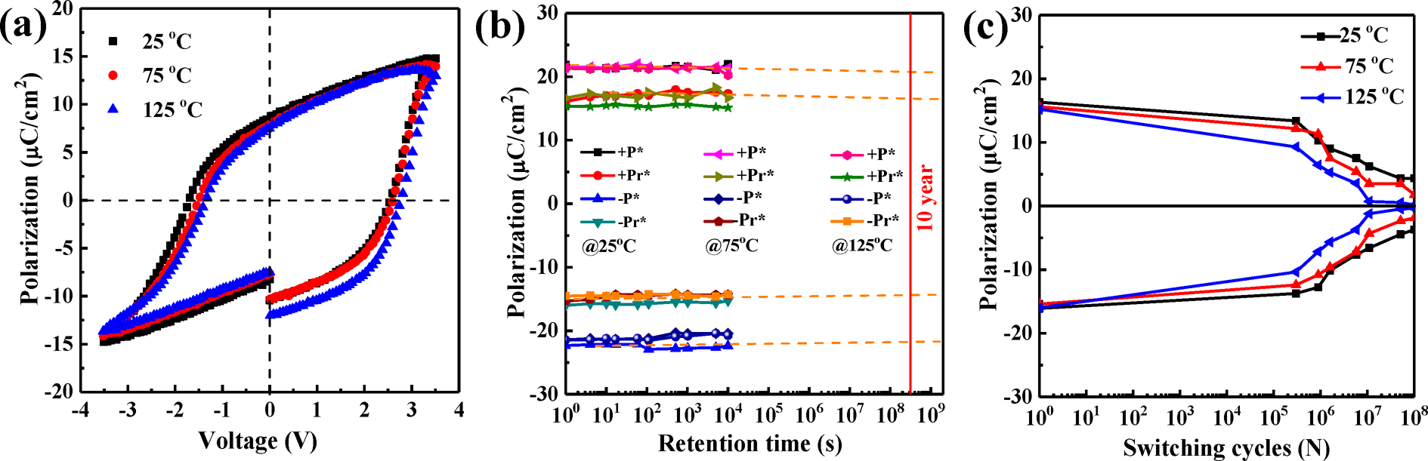

Figure 2. (a) P−V hysteresis loops. (b) Retention and (c) endurance of the annealed TaN/HZO/TaN/mica flexible capacitor at various temperatures.

induces an obvious peak at 30.5°, which is absent in the as-fabricated HZO film, suggesting that the film is crystallized after the annealing process. In general, this peak could be ascribed to the mixed phases of cubic, tetragonal, and orthorhombic in HfO2 thin films. However, because of their similar lattice parameters, it is difficult to unambiguously and quantitatively identify these phases.31−40Among these phases, the orthorhombic phase is considered to be the cause of ferroelectricity.31−40Particularly, during thermal annealing process, the ferroelectric orthorhombic phase could be stabilized or promoted in HfO2-based films, and this process normally requires high crystallization temperature. For HZO films, annealing at ∼500 °C is required to achieve feasible ferroelectricity.24As mentioned before, polyimide was utilized as the substrate for flexible HfO2-based films. However, even after optimization of the annealing process, temperatures higher than 430 °C could not be applied, and prolonged annealing at 380 °C for 150 s resulted in a decrease in the ferroelectricity of remnant polarization.30Besides, HfO2 films doped with elements other than Zr demand an even higher temperature to attain ferroelectricity.24Rationally, insufficient annealing to form the ferroelectric phase would weaken the polarization.30Consequently, mica with high thermal stability proves to be a promising substrate for high temperature induced orthorhombic phase formation in HfO2-based thin films. Furthermore, given the limit in GIXRD to distinguish the above-mentioned coexistent phases, transmission electron microscopy (TEM) is performed. Figure 1b shows the cross-sectional TEM image. The MFM capacitor structure exhibits clear interfaces, and the HZO film thickness is ∼18 nm. Figure 1c illustrates the cross-sectional high resolution TEM (HRTEM) images, and the inset figure shows the enlarged HRTEM image of the selected area marked by a red frame. The lattice fringes of the selected HZO areas reveal the orthorhombic phase (111) plane with an interplanar distance of 2.94 Å, demonstrating the formation of the ferroelectric phase of the HZO film in the annealed TaN/HZO/TaN/mica structure. Combining these structural analyses, ferroelectricity could be predicted for the capacitor with the annealed HZO film. The polarization−voltage (P−V) hysteresis loops between 1 and 105bipolar switching cycles of the annealed TaN/HZO/TaN/mica flexible capacitor under an applied voltage of 3.5 V are evaluated and displayed in Figure 1d. Because of the pulse frequency limitation to 1 kHz of the test equipment, we tested the P−V loops 10 times manually to obtain the data of 10 bipolar switching cycles. After 103bipolar

921 DOI: [10.1021/acsaelm.9b00107](http://dx.doi.org/10.1021/acsaelm.9b00107)

|  |  |
| --- | --- |
| ACS Applied Electronic Materials | Article |

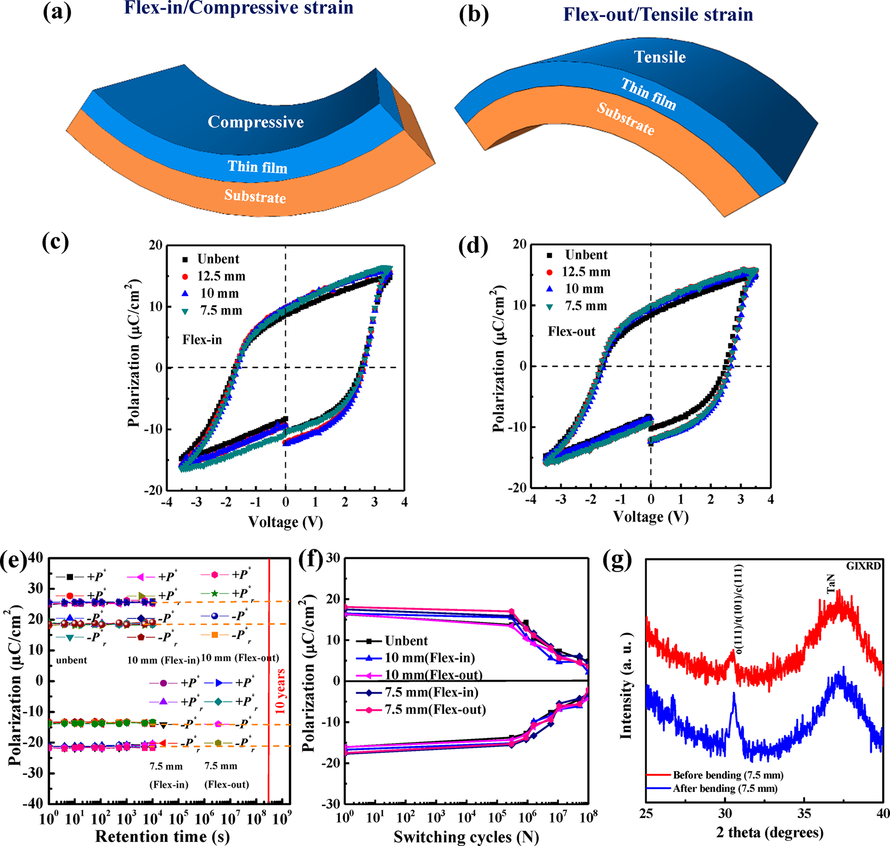

Figure 3. (a) Flex-in/compressive strain mode and (b) flex-out/tensile strain mode of the thin film. (c) P−V hysteresis loops under various compressive bending radii. (d) P−V hysteresis loops under various tensile bending radii. (e) Retention and (f) endurance for the TaN/HZO/ TaN/mica capacitors in unbent and compressive and tensile bending conditions after 1000 bending cycles. (g) GIXRD patterns of the TaN/HZO/ TaN/mica structure before and after bending.

characteristics is comparable to that of the reported ferro-electric HfO2-based FeRAM.44In fact, it is reported that with very high density of bits an endurance of 104cycles could be sufficient for many applications.24Moreover, by optimization on operation conditions, film thickness, and so on, it is possible to achieve an improved endurance.24,45   
 Figure 2a shows the P−V curves of the annealed flexible MFM capacitor at different temperatures from 25 to 125 °C. The ferroelectric capacitor demonstrates a 2Pr ∼ 18 μC/cm2 and a 2Ec ∼ 2.1 MV/cm at 25 °C. With elevated temperatures, a slight positive shift in the coercive field for P−V loop appears.

Probably, higher temperature is more helpful to stimulate electron−hole pairs, oxygen vacancies, and subsequent charge trapping, which lead to a built-in field. Consequently, the built-in field affects the voltage imposed on ferroelectric domains and thus induces the voltage shift.46−48Therefore, the slight shift may suggest a low built-in field due to the large bandgap and stability of the HZO film in the capacitor. The

temperature dependence of the retention is also examined in this work. These flexible MFM capacitors sustain excellent retention, as shown in Figure 2b, even after 104s at 25 °C and

922 DOI: [10.1021/acsaelm.9b00107](http://dx.doi.org/10.1021/acsaelm.9b00107)

|  |  |
| --- | --- |
| ACS Applied Electronic Materials | Article |

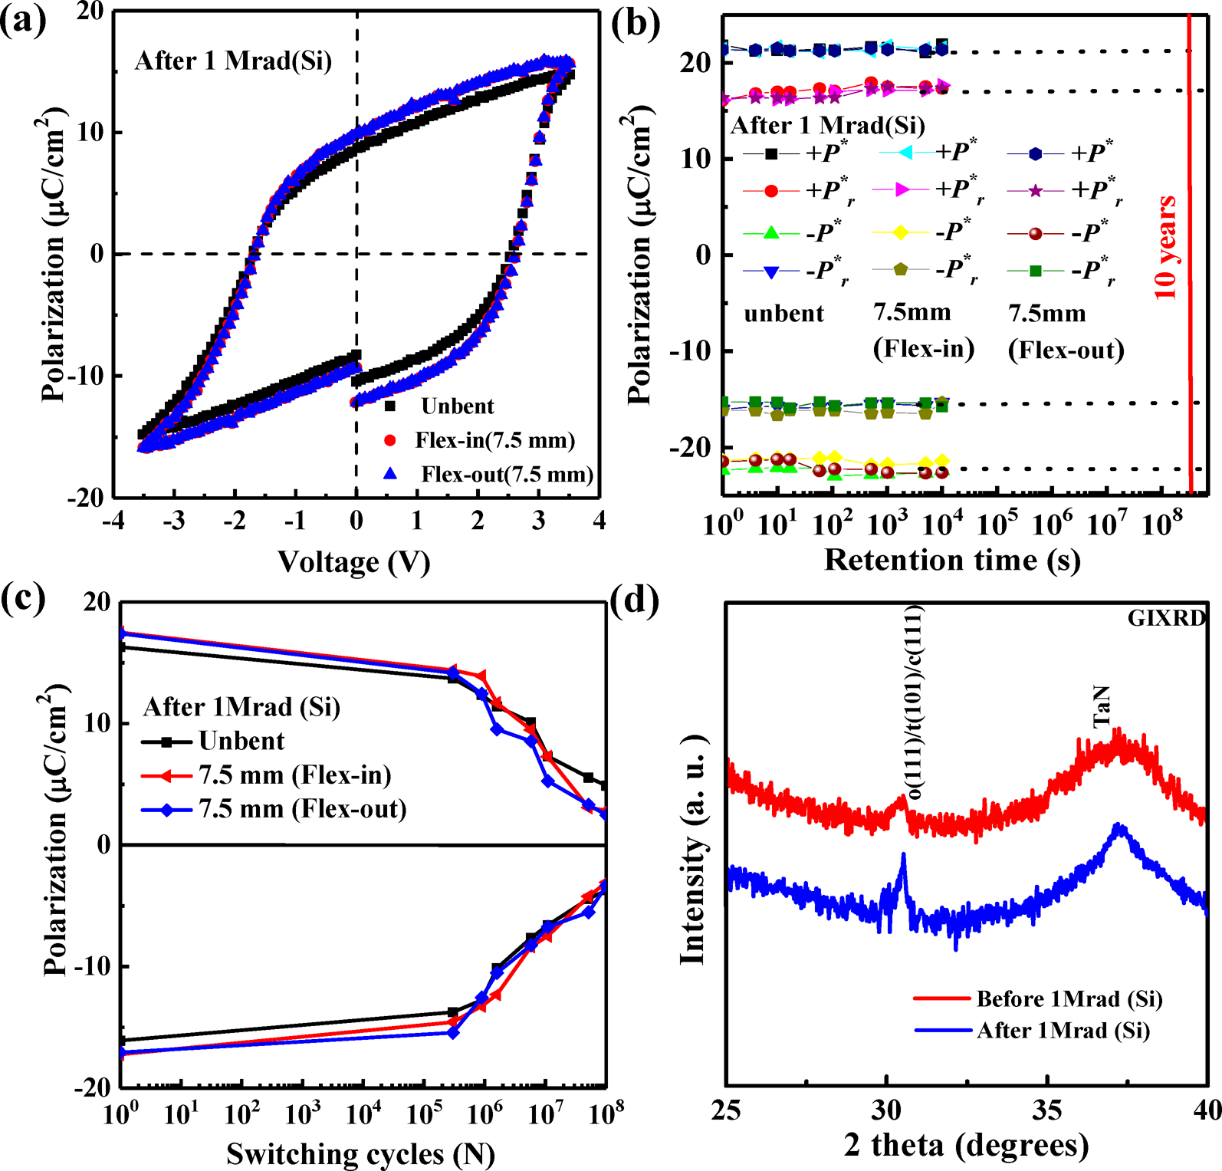

Figure 4. (a) P−V hysteresis loops. (b) Retention and (c) endurance of the annealed TaN/HZO/TaN/mica flexible MFM capacitors under tensile and compressive bending of 7.5 mm for 1000 bending cycles after radiation. (d) GIXRD patterns of the TaN/HZO/TaN/mica structure before and after radiation.

when the bend radius is reduced to 7.5 mm. In addition, for the capacitor under bending state with 7.5 mm radius after 1000 bending cycles, the P−V hysteresis loops at an applied voltage of 3.5 V between 1 and 105bipolar switching cycles were measured and are shown in [Figure S3](http://pubs.acs.org/doi/suppl/10.1021/acsaelm.9b00107/suppl_file/el9b00107_si_001.pdf). The test process is the same as that in Figure 1d. Similarly, an expanding of polarization and coercive field with the increasing bipolar switching cycles could be observed. Figure 3e shows the retention of the annealed TaN/HZO/TaN/mica flexible capacitors in unbent, flex-in/compressive, and flex-out/tensile strain modes. Here, the applied voltage is fixed at 3.5 V, and the bending radius is changed from 10 to 7.5 mm. Noteworthy, the flexible capacitors exhibit excellent retention in both compressive and tensile bending conditions even after 1000 bending cycles. Furthermore, under bending conditions, the mica-based flexible capacitor could still reserve excellent retention properties after 104s, with an extrapolated retention time to failure longer than 10 years. Additionally, for the capacitor under bending state with 7.5 mm radius after 1000 bending cycles, a test with an extended retention time of 105s was carried out, and it still shows no polarization degradation, as shown in [Figure S4](http://pubs.acs.org/doi/suppl/10.1021/acsaelm.9b00107/suppl_file/el9b00107_si_001.pdf). However, retention is not available with the flexible HZO [f](http://pubs.acs.org/doi/suppl/10.1021/acsaelm.9b00107/suppl_file/el9b00107_si_001.pdf)ilm on polyimide after bending, and it was reported that with a bending radius of 8 mm the ferroelectricity endures repetitive bending up to 1000 cycles,

923 DOI: [10.1021/acsaelm.9b00107](http://dx.doi.org/10.1021/acsaelm.9b00107)

|  |  |
| --- | --- |
| ACS Applied Electronic Materials | Article |

Table 1. Properties of Several Flexible Ferroelectric Memory Devicesa

|  |  |  |  |  |  |  |  |  |  |
| --- | --- | --- | --- | --- | --- | --- | --- | --- | --- |
| ferroelectric material | HZO | HZO | PZT20 | PLZT | BLT | BFOMnTi | PZT48 | P(VDF-TrFE) | |
| substrate | mica | PI | mica | mica | mica | mica | silicon | Si | PDMS |
| deposition technique | ALD | ALD | PLD | PLD | PLD | CSD | sol−gel | spin-coating | |
| thickness of ferroelectric material (nm) | 18 | 30 | N/A | 100 | 100−300 | 300 | 280 | 200 | 340 |
| Pr (μC/cm2) | ∼11 | 10 | 60 | ∼41 | ∼10 | 66  Ec + ∼ 844,  Ec− ∼ 276 | 18 | ∼5.4 | ∼9 |
| Ec (kV/cm) | 1150 | N/A | 100 | ∼290 | ∼80 | 60 | ∼1200 | ∼415 |
| retention (years) | >10 | N/A | >10 | >105s | >10 | 105s | >10 | N/A | N/A |
| fatigue (bipolar   switching cycles) | 108 | N/A | >1010 | 1010 | 109 | 109 | 109(unbent), >1010(bent) | N/A | <105   (unbent) |
| minimum bending radius (mm) | 7.5 | 5 | 2.5 | 5 | 1.4 | 2 | 5 | N/A | N/A |
| bending cycles | 1000 at   7.5 mm | 1000 at 8 mm | >1000 at 5 mm | 1000 at 5 mm | 10000 at 1.4 mm | 1000 at 4 mm | 1000 at 5 mm | N/A | N/A |
| switching time | N/A | N/A | 2000 ns | N/A | N/A | N/A | 500 ns | N/A | N/A |
| working temp (°C) | 125 | N/A | 175 | N/A | 200 | N/A | N/A | N/A | N/A |
| radiation dose (Mrad (Si)) | 1 | N/A | N/A | 5 | N/A | N/A | N/A | N/A | N/A |
| reference | this work | 30 | 22 | 23 | 21 | 54 | 11, 12 | 55 | 56 |

aPZT20: PbZr0.2Ti0.8O3; PLZT: Pb0.9La0.1(Zr0.7Ti0.3)O3; BLT: Bi3.25La0.75Ti3O12; BFOMnTi: Bi(Fe0.93Mn0.05Ti0.02)O3; PZT48: Pb1.1Zr0.48Ti0.52O3; P(VDF-TrFE): poly(vinylidene−trifluoroethylene); PI: polyimide; PDMS: polydimethylsiloxane; ALD: atomic layer deposition; PLD: pulsed laser deposition; CSD: chemical solution deposition.

characterized by GIXRD, and the results are demonstrated in Figure 3g. Similarly, the peak at 30.5° stays nearly unchanged before and after bending. In combination with the P−V characteristics, the ferroelectric orthorhombic phase could be verified. The stable retention and endurance performance against mechanical stress may profit from the ultrathin thickness of the ferroelectric HZO film, which is also suggested in the flexible HZO-based capacitor with polyimide sub-strate.30Therefore, the fabricated HZO NVM capacitors are demonstrated to be suitable for highly desirable flexible device applications.

Figure 4a shows the P−V hysteresis loops of the TaN/ HZO/TaN/mica capacitor after exposing to 1 Mrad (Si) radiation. In addition, the ferroelectricity under compressive and tensile strain modes after radiation is explored. The values of the 2Pr and 2Ec are slightly larger than those of the pristine state, which is consistent with previous results in the bending test and may be attributed to the promotion from the large in-plane tensile stress to form the orthorhombic phase.50After 1 Mrad (Si) radiation, the ferroelectric properties do not show noticeable change regardless of the mechanical constraints. This stable performance is substantially better than traditional ferroelectric materials such as PZT and SBT reported so far51,52and is consistent with the reported results of Y-HfO2-based ferroelectric memory.48,53Figure 4b displays the constant retention behaviors of the TaN/HZO/TaN/mica capacitors in unbent and bent states after 1 Mrad (Si) radiation. Deserving of emphasis, Figure 4c again exhibits the similar endurance characteristics to the above-mentioned results, with which serious degradation shows up after 106 bipolar switching cycles. Taking the endurance of the capacitor with a bending radius of 7.5 mm for an example, after radiation and then 1000 bending cycles, the 2Pr decreases from 32.4 to 30 μC/cm2after 105bipolar switching cycles, and it drops to 26 μC/cm2(80%) after 106bipolar switching cycles. On the basis of these observations, it is suggested that external factors as temperature, mechanical stress, and γ-ray radiation in this work have a negligible influence on the performance of the flexible HZO-based capacitor. Significantly, the intrinsic

924 DOI: [10.1021/acsaelm.9b00107](http://dx.doi.org/10.1021/acsaelm.9b00107)

|  |  |  |  |  |  |
| --- | --- | --- | --- | --- | --- |
| ACS Applied Electronic Materials | | |  | |  | | --- | | Article | |
| moved to an atomic layer deposition (ALD) chamber for growth of ferroelectric HZO films. [(CH3)2N]4Hf (TDMAHf) was used for Hf precursor, and [(CH3)2N]4Zr (TDMAZr) was used for Zr precursor. | | | 925 | ■ACKNOWLEDGMENTS  This work was financially supported by the National Natural |
| Science Foundation of China (Grant No. 51702273), the |
| H2O was used for oxygen source in the ALD chamber. An alternative cycle formulation of HfO2 and ZrO2 is used to achieve a doping ratio of Hf:Zr = 1:1. After deposition of the HZO film, 100 nm thick TaN | | |
| “Huxiang Young Talents Plan” Support Project of Hunan |
| Province (Grant No. 2018RS3087), and the Science and |
| electrodes were deposited by reactive magnetron sputtering and | | | Technology Innovation Project of Hunan Province (Grant No. |
| patterned by photolithography and reactive ion etching techniques, | | | 2017XK2048).  ■REFERENCES |
| and the top electrode area for the TaN/HZO/TaN/mica structures was 4 × 10−4cm2. Finally, the whole device was annealed by using a rapid thermal annealing at 500 °C for 30 s in ambient N2. The | | |
| (1) Scott, J. F.; Paz de Araujo, C. A. Ferroelectric memories. Science 1989, 246 (4936), 1400−1405. |
| ferroelectric properties of the TaN/HZO/TaN/mica were measured | | |
| by an RT66A measurement system. A heating stage was used to | | |
| (2) Arimoto, Y.; Ishiwara, H. Current status of ferroelectric random-access memory. MRS Bull. 2004, 29 (11), 823−828. |
| change the measurement temperature to estimate the ferroelectric performance along with the temperature ranging from 25 to 125 °C. The structural properties of the HZO thin films were investigated by grazing incidence X-ray diffraction (GIXRD), and transmission | | |
| (3) Kawashima, S.; Morita, K.; Nakazawa, M.; Yamane, K.; Ogai, M.; |
| Kawabata, K.; Takai, K.; Fujii, Y.; Yasuda, R.; Wang, W.; Hikosaka, Y.; |
| electron microscopy (TEM). For the bending test, predesigned Teflon molds with different fixed bending radii were used to implement a flex-in mode (thin film under compression) and flex-out mode (thin film under tension). It is noted that all bending results of the flexible MFM capacitor were measured under the bending state after 1000 bending cycles. The radiation source of this work is60Co γ- | | | Inoue, K. An 8-Mbit 0.18-μm CMOS 1T1C FeRAM in planar technology. IEICE Trans. Electron. 2015, 98 (11), 1047−1057. |
| (4) Davenport, T.; Mitra, S. Process variations in use for the first generations of FRAM® memory products. Integr. Ferroelectr. 2000, 31 (1−4), 213−231. |
| (5) Fan, Z.; Chen, J.; Wang, J. Ferroelectric HfO2-based materials for |
| rays, and irradiations were performed at dose levels: 1 Mrad (Si) with | | | next-generation ferroelectric memories. J. Adv. Dielectr. 2016, 6 (02), |
| a radiation rate of 127 rad/s. During the radiation, TaN/HZO/TaN/ mica MFM flexible capacitors were in open circuit state, and γ-rays are from a uniform radiation field. It is noted that all irradiated results of the flexible MFM capacitor were measured after the absorbed | | | 1630003. |
| (6) Kuribara, K.; Wang, H.; Uchiyama, N.; Fukuda, K.; Yokota, T.; |
| Zschieschang, U.; Jaye, C.; Fischer, D.; Klauk, H.; Yamamoto, T.; |
| et al. Organic transistors with high thermal stability for medical |
| radiation.  ■ASSOCIATED CONTENT | | | applications. Nat. Commun. 2012, 3, 723. |
| (7) Boufouss, E. H.; Francis, L. A.; Kilchytska, V.; Gérard, P.; Simon, |
| P.; Flandre, D. Ultra-low power high temperature and radiation hard |
| complementary metal-oxide-semiconductor (CMOS) silicon-on-in-sulator (SOI) voltage reference. Sensors 2013, 13 (12), 17265−17280. |
| * | Supporting Information | |
| The Supporting Information is available free of charge on the | | | (8) Bao, Z.; Chen, X. Flexible and stretchable devices. Adv. Mater. 2016, 28 (22), 4177−4179. |
| [ACS Publications website](http://pubs.acs.org) at DOI: [10.1021/acsaelm.9b00107](http://pubs.acs.org/doi/abs/10.1021/acsaelm.9b00107). | | |
| (9) Ghoneim, M. T.; Hussain, M. M. Review on physically flexible |
| Test sequences used for measuring the polarization−voltage (P−V) hysteresis loops between 1 and 105 | | |
| nonvolatile memory for internet of everything electronics. Electronics 2015, 4 (3), 424−479. |
| bipolar switching cycles of the annealed TaN/HZO/ TaN/mica flexible capacitor (Figure S1); test sequences | | | (10) Zuo, Z.; Chen, B.; Zhan, Q.-f.; Liu, Y.; Yang, H.; Li, Z.; Xu, G.; |
| Li, R.-W. Preparation and ferroelectric properties of freestanding |
| for endurance measurement of the annealed TaN/ HZO/TaN/mica flexible capacitor (Figure S2); P−V hysteresis loops of the TaN/HZO/TaN/mica flexible | | | Pb(Zr, Ti)O3 thin membranes. J. Phys. D: Appl. Phys. 2012, 45 (18), 185302. |
| (11) Ghoneim, M. T.; Hussain, M. M. Study of harsh environment |
| operation of flexible ferroelectric memory integrated with PZT and |
| MFM capacitor under bending state with 7.5 mm radius after 1000 bending cycles (between 1 and 105bipolar | | |
| silicon fabric. Appl. Phys. Lett. 2015, 107 (5), 052904. |
| (12) Ghoneim, M. T.; Zidan, M. A.; Alnassar, M. Y.; Hanna, A. N.; |
| switching cycles) (Figure S3); retention of the TaN/ HZO/TaN/mica flexible MFM capacitor under bending | | |
| Kosel, J.; Salama, K. N.; Hussain, M. M. Thin PZT-based ferroelectric |
| capacitors on flexible silicon for nonvolatile memory applications. Adv. |
| state with 7.5 mm radius after 1000 bending cycles (Figure S4); metallographic micrographs of the flexible MFM capacitor after different bending cycles with a | | | Electron. Mater. 2015, 1 (6), 1500045. |
| (13) Rho, J.; Kim, S. J.; Heo, W.; Lee, N.-E.; Lee, H.-S.; Ahn, J.-H. |
| PbZrxTi1‑xO3 Ferroelectric thin-film capacitors for flexible nonvolatile memory applications. IEEE Electron Device Lett. 2010, 31 (9), 1017− |
| bending radius of 7.5 mm (Figure S5) ([PDF](http://pubs.acs.org/doi/suppl/10.1021/acsaelm.9b00107/suppl_file/el9b00107_si_001.pdf)) | | |
| ■AUTHOR INFORMATION | | | 1019. |
| (14) Chen, S.; Yao, K.; Tay, F. E. H.; Chew, L. L. S. Comparative |
| investigation of the structure and properties of ferroelectric poly (vinylidene fluoride) and poly (vinylidene fluoride−trifluoroethylene) |
| Corresponding Authors | | |
| thin films crystallized on substrates. J. Appl. Polym. Sci. 2010, 116 (6), 3331−3337. |
| *E-mail [shuaizhi@xtu.edu.cn](mailto:shuaizhi@xtu.edu.cn) (S.Z.). *E-mail [mliao@xtu.edu.cn](mailto:mliao@xtu.edu.cn) (M.L.).  *E-mail [cfzhang@xidian.edu.cn](mailto:cfzhang@xidian.edu.cn) (C.Z.). | | |
| (15) Yoon, S.-M.; Jung, S.-W.; Yang, S.; Park, S.-H. K.; Yu, B.-G.; |
| Ishiwara, H. Bending characteristics of ferroelectric poly (vinylidene |
| ORCID | |  | fluoride trifluoroethylene) capacitors fabricated on flexible poly-ethylene naphthalate substrate. Curr. Appl. Phys. 2011, 11 (3), S219− |
| Shuaizhi Zheng: [0000-0003-0209-7769](http://orcid.org/0000-0003-0209-7769) | | |
| S224. |
| Chunfu Zhang: [0000-0001-9555-3377](http://orcid.org/0000-0001-9555-3377) | | |
| (16) Tong, Y.; Liu, B.; Lim, P. S. Y.; Yeo, Y.-C. Selenium segregation for effective Schottky barrier height reduction in NiGe/n−Ge contacts. IEEE Electron Device Lett. 2012, 33 (6), 773−775. |
| Jincheng Zhang: [0000-0001-7332-6704](http://orcid.org/0000-0001-7332-6704) | | |
| Author Contributions | | |
| (17) Horiuchi, S.; Tokura, Y. Organic ferroelectrics. Nat. Mater. |
| W.X. and C.L. contributed equally to this work. | | |
| 2008, 7 (5), 357. |
| Notes | | |
| (18) Horiuchi, S.; Tokunaga, Y.; Giovannetti, G.; Picozzi, S.; Itoh, |
| The authors declare no competing financial interest. | | | H.; Shimano, R.; Kumai, R.; Tokura, Y. Above-room-temperature |
| DOI: [10.1021/acsaelm.9b00107](http://dx.doi.org/10.1021/acsaelm.9b00107)  ACS Appl. Electron[. Mater. 2019, 1, 919−927](http://dx.doi.org/10.1021/acsaelm.9b00107) |

|  |  |
| --- | --- |
| ACS Applied Electronic Materials | Article |

ferroelectricity in a single-component molecular crystal. Nature 2010, 463 (7282), 789.

(19) Tang, Y.-Z.; Yu, Y.-M.; Tan, Y.-H.; Wu, J.-S.; Xiong, J.-B.; Wen, H.-R. Two acentric (6, 3) topological 2-D frameworks with imidazole-containing tripodal ligand and their ferroelectric properties. Dalton Trans. 2013, 42 (28), 10106−10111.

(20) Han, S. T.; Zhou, Y.; Roy, V. Towards the development of flexible non-volatile memories. Adv. Mater. 2013, 25 (38), 5425−5449.

(21) Su, L.; Lu, X.; Chen, L.; Wang, Y.; Yuan, G.; Liu, J.-M. Flexible, fatigue-free and large-scale Bi3. 25La0. 75Ti3O12 ferroelectric memories. ACS Appl. Mater. Interfaces 2018, 10, 21428−21433.

(22) Jiang, J.; Bitla, Y.; Huang, C.-W.; Do, T. H.; Liu, H.-J.; Hsieh, Y.-H.; Ma, C.-H.; Jang, C.-Y.; Lai, Y.-H.; Chiu, P.-W.; Wu, W.-W.; Chen, Y.-C.; Zhou, Y.-C.; Chu, Y.-H. Flexible ferroelectric element based on van der Waals heteroepitaxy. Sci. Adv. 2017, 3 (6), No. e1700121.

(23) Ma, C.-H.; Jiang, J.; Shao, P.-W.; Peng, Q.-X.; Huang, C.-W.; Wu, P.-C.; Lee, J.-T.; Lai, Y.-H.; Tsai, D.-P.; Wu, J.-M.; Lo, S.-C.; Wu, W.-W.; Zhou, Y.-C.; Chiu, P.-W.; Chu, Y.-H. Transparent antiradiative ferroelectric heterostructure based on flexible oxide heteroepitaxy. ACS Appl. Mater. Interfaces 2018, 10 (36), 30574−30580.

(24) Park, M. H.; Lee, Y. H.; Kim, H. J.; Kim, Y. J.; Moon, T.; Kim, K. D.; Müller, J.; Kersch, A.; Schröder, U.; Mikolajick, T.; Hwang, C. S. Ferroelectricity and antiferroelectricity of doped thin HfO2-based films. Adv. Mater. 2015, 27 (11), 1811−1831.

(25) Park, M. H.; Lee, Y. H.; Mikolajick, T.; Schröder, U.; Hwang, C. S. Review and perspective on ferroelectric HfO2-based thin films for memory applications. MRS Commun. 2018, 8 (3), 795−808. (26) Wei, Y.; Nukala, P.; Salverda, M.; Matzen, S.; Zhao, H. J.; Momand, J.; Everhardt, A.; Blake, G. R.; Lecoeur, P.; Kooi, B. J.; et al. A rhombohedral ferroelectric phase in epitaxially-strained Hf0. 5Zr0. 5O2 thin films. Nat. Mater. 2018, 17, 1095−1100.

(27) Hoffmann, M.; Fengler, F. P.; Herzig, M.; Mittmann, T.; Max, B.; Schröder, U.; Negrea, R.; Lucian, P.; Slesazeck, S.; Mikolajick, T. Unveiling the double-well energy landscape in a ferroelectric layer. Nature 2019, 565, 464−467.

(28) Müller, J.; Böscke, T.; Bräuhaus, D.; Schröder, U.; Böttger, U.; Sundqvist, J.; Kücher, P.; Mikolajick, T.; Frey, L. Ferroelectric Zr0.5Hf0.5O2 thin films for nonvolatile memory applications. Appl. Phys. Lett. 2011, 99 (11), 112901.

(29) Chernikova, A.; Kozodaev, M.; Markeev, A.; Negrov, D.; Spiridonov, M.; Zarubin, S.; Bak, O.; Buragohain, P.; Lu, H.; Suvorova, E.; Gruverman, A.; Zenkevich, A. Ultrathin Hf0. 5Zr0. 5O2 ferroelectric films on Si. ACS Appl. Mater. Interfaces 2016, 8 (11), 7232−7237.

(30) Yu, H.; Chung, C. C.; Shewmon, N.; Ho, S.; Carpenter, J. H.; Larrabee, R.; Sun, T.; Jones, J. L.; Ade, H.; O’Connor, B. T.; So, F. Flexible inorganic ferroelectric thin films for nonvolatile memory devices. Adv. Funct. Mater. 2017, 27 (21), 1700461.

(31) Florent, K.; Lavizzari, S.; Piazza, L. D.; Popovici, M.; Vecchio, E.; Potoms, G.; Groeseneken, G.; IHoudt, J. V. First Demonstration of Vertically Stacked Ferroelectric Al-Doped HfO2 Devices for NAND Applications in 2017 Symposium on VLSI Technology; IEEE: pp T158−T159.

(32) Lu, Y. W.; Shieh, J.; Tsai, F. Y. Induction of ferroelectricity in nanoscale ZrO2/HfO2 bilayer thin films on Pt/Ti/SiO2/Si substrates. Acta Mater. 2016, 115, 68−75.

(33) Chernikova, A. G.; Kozodaev, M. G.; Negrov, D. V.; Korostylev, E. V.; Park, M. H.; Schröder, U.; Hwang, C. S.; Markeev, A. M. Improved ferroelectric switching endurance of La-doped Hf0.5Zr0.5O2 thin films. ACS Appl. Mater. Interfaces 2018, 10 (3), 2701−2708.

(34) Lee, Y. H.; Hyun, S. D.; Kim, H. J.; Kim, J. S.; Yoo, C.; Moon, T.; Kim, K. D.; Park, H. W.; Lee, Y. B.; Kim, B. S.; Roh, J.; Park, M. H.; Hwang, C. S. Nucleation-limited ferroelectric orthorhombic phase formation in Hf0.5Zr0.5O2 thin films. Advanced Electronic Materials. 2019, 5 (2), 1800436.

926 DOI: [10.1021/acsaelm.9b00107](http://dx.doi.org/10.1021/acsaelm.9b00107)

|  |  |
| --- | --- |
| ACS Applied Electronic Materials | Article |

(53) Huang, F.; Wang, Y.; Liang, X.; Qin, J.; Zhang, Y.; Yuan, X.;   
Wang, Z.; Peng, B.; Deng, L.; Liu, Q.; Bi, L.; Liu, M. HfO2-based   
highly stable radiation-immune ferroelectric memory. IEEE Electron   
Device Lett. 2017, 38 (3), 330−333.

(54) Yang, C.; Han, Y.; Qian, J.; Lv, P.; Lin, X.; Huang, S.; Cheng, Z.   
Flexible, temperature-resistant, and fatigue-free ferroelectric memory   
based on Bi(Fe0.93Mn0.05Ti0.02)O3 thin film. ACS Appl. Mater.   
Interfaces 2019, 11 (13), 12647−12655.

(55) Almadhoun, M. N.; Khan, M. A.; Rajab, K.; Park, J. H.; Buriak,   
J. M.; Alshareef, H. N. UV-induced ferroelectric phase transformation   
in PVDF thin films. Adv. Electron. Mater. 2019, 5 (1), 1800363.   
(56) Jung, S.-W.; Choi, J.-S.; Koo, J. B.; Park, C. W.; Na, B. S.; Oh,   
J.-Y.; Lim, S. C.; Lee, S. S.; Chu, H. Y.; Yoon, S.-M. Flexible   
nonvolatile organic ferroelectric memory transistors fabricated on   
polydimethylsiloxane elastomer. Org. Electron. 2015, 16, 46−53.   
(57) Dai, Y.-W.; Chen, L.; Yang, W.; Sun, Q.-Q.; Zhou, P.; Wang, P.-  
F.; Ding, S.-J.; Zhang, D. W.; Xiao, F. Complementary resistive   
switching in flexible RRAM devices. IEEE Electron Device Lett. 2014,   
35 (9), 915−917.

|  |  |
| --- | --- |
| 927 | DOI: [10.1021/acsaelm.9b00107](http://dx.doi.org/10.1021/acsaelm.9b00107) ACS Appl. Electron[. Mater. 2019, 1, 919−927](http://dx.doi.org/10.1021/acsaelm.9b00107) |